CSE460: VLSI Design Handout (Spring 2026)

Communication platform:

CSE460 Spring 2026 Official Discord Server: https://discord.gg/v5GUBpGhVs

Course Outcomes and Contents:

Course Outline:

Course Outcomes |  | Course Contents
CO1 | Before Midterm | - Review of Digital Logic Design,  - Logic design with CMOS,  - CMOS DC Response
CO2 |  | - Finite State Machine design with logic gates
CO3 |  | - Delay and Power considerations in CMOS logic circuits
CO4 |  | - Algorithms in Physical Design - Partitioning Algorithm and Routing Algorithm

CO Description and Weightage
Sl. | CO Description | Weightage (%)
CO1 | Design combinational and sequential circuits in CMOS by demonstrating the current voltage relationship and the dc response, and compute the noise margin of CMOS circuits. | 30%
CO2 | Construct system design process using finite state machines and hardware description language. | 25%
CO3 | Analyze the power dissipation and propagation delay of CMOS circuits. | 25%
CO4 | Devise algorithms to design and optimize the physical layout of an IC. | 20%

Marks distribution:
Theory/Lab | Assessment | Percentage | Total number of assessments | Number of assessments to be graded
Theory  (75%) | Attendance | 5% | - | 70% (90%+ for lab) or more to be eligible for Final Exam
 | Assignment | 5% | Count at least 2 | Variable section-wise
 | Quiz* | 15% | Count at least 3 | Best (n-1)
 | Midterm | 25% | 1 | 1
 | Final | 25% | 1 | 1
Lab  (25%) | Lab Performance | 12% | 5 (n) | Best (n-2)
 | Lab-test | 6%+7% | 2 | 2
*The last quiz (n^{th} quiz) will be considered as a make-up for any missed quiz (maximum of 1), whatever the reason. No other make-up quizzes will be taken.

Routine & Course Team:

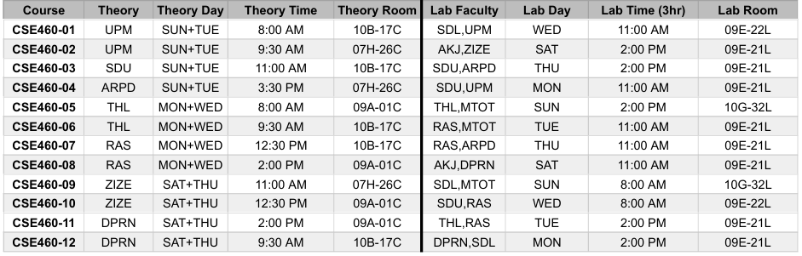

Course Team
Initial | Name | BRACU Email
ARPD | Arpa Roy Dastider | ext.arpa.roy@bracu.ac.bd
AKJ | Akib Anjum | anjum.akib@bracu.ac.bd
MTOT | Md Toky Tazwar | ext.toky.tazwar@bracu.ac.bd
SDU | Shomen Kundu | shomen.kundu@bracu.ac.bd
THL | Mohammad Tahsin Alam | tahsin.alam@bracu.ac.bd
UPM | Tasnim Sobhan Upoma | tasnim.upoma@bracu.ac.bd
RAS | Md. Rasel Mia | rasel.mia@bracu.ac.bd
DPRN | Dipika Rani Nath | ext.dipika.rani@bracu.ac.bd
ZIZE | Zahin Iqbal Zeal | ext.zahin.ikbal@bracu.ac.bd
SDL | Shadmin Sultana | ext.shadmin.sultana@bracu.ac.bd

Schedule ( Theory and Lab ):
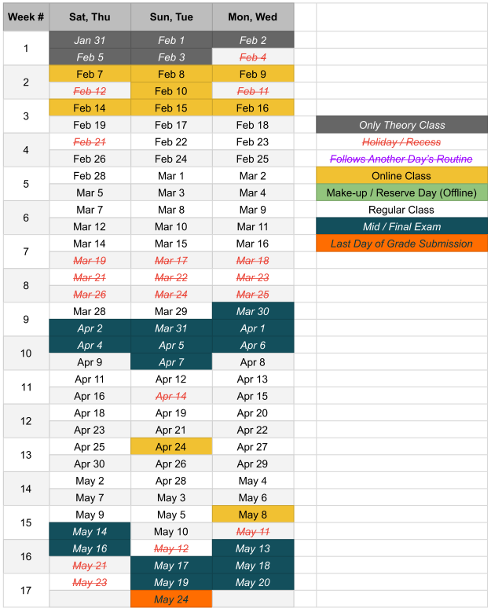

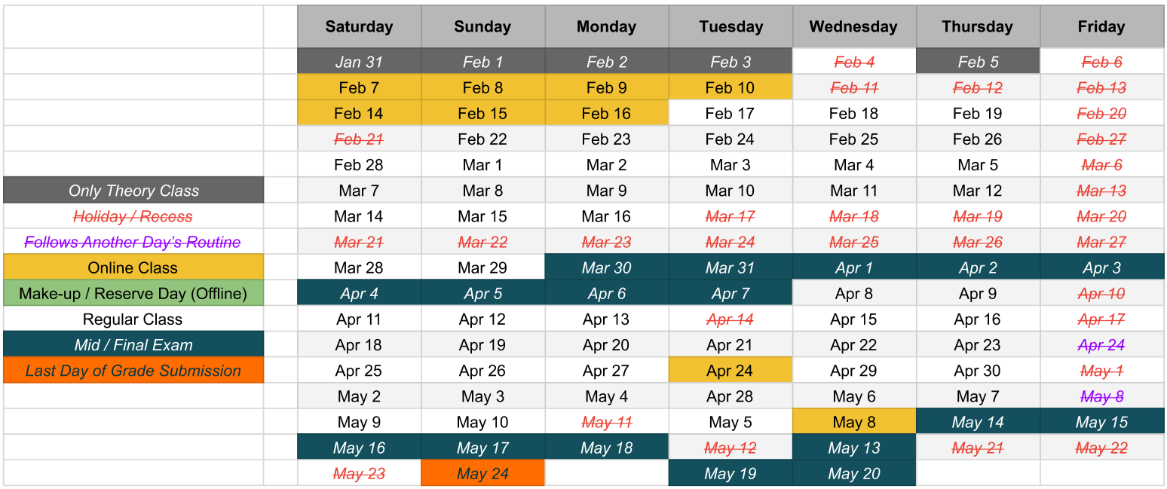

Lab Schedule and Policy

( need to update )

CSE-460 Tentative Lab Schedule
Sat | Sun | Mon | Tue | Wed | Thurs
Sat | Sun | Mon | Tue | Wed | Thurs

Lab policies:

- No make-up of lab will be considered without valid reason. You need to submit valid medical documents in order to sit with any other section and obtain the permission from that section’s lab faculties, keeping your original lab faculties in the cc of the mail.

- Make-up labs must be done by attending lab class with other sections. No make-up lab assessment shall be held during the consultation period.

- If a student arrives more than 20 minutes after the lab has started, he/she will be marked as late. Late attendees will face a 30% deduction in their assessment marks for that particular day. If they arrive more than one hour after the lab has begun, they will be considered absent and must make up the class with another section.

Course contents
Detailed List of Topics
Introduction to VLSI (Very Large Scale Integration) design: history, IC trends, technology & design approaches. Moore’s law. Review of digital logic design.
Introduction to logic circuit families: n-MOS, p-MOS, pseudo n-MOS and CMOS technologies. Introduction to CMOS logic. Pull-up and pull-down networks, implementation using series and parallel MOSFETs. Combinational logic circuit design using CMOS. Complex gate design using CMOS such as And-Or-Invert or Or-And-Invert. Implementation of different circuit elements like basic gates. Multiplexers, encoder, latch, flip-flops using CMOS.
Introduction to FSM (Finite State Machine): Moore type & Mealy type FSM hardware implementation. State encoding & minimization techniques.
DC Response of CMOS gates: n-MOS & p-MOS pass transistors. Logic levels and noise margins. DC transfer characteristics.
CMOS Power: instantaneous and average power, energy. Power analysis of circuit elements (R, C, DC Supply). Switching waveforms of an inverter. Static power and Dynamic power. Activity factor. Power reduction techniques: Clock gating, Power gating, Dynamic voltage scaling.
Transient response of CMOS gates. Delay definitions: rise time, fall time, propagation delay and contamination delay, RC delay model. Effective resistance & capacitance. Elmore delay. Parasitic and effort delay. Fan-in and fan-out. Layout comparisons.
Physical design of ICs: floorplanning, partitioning, routing, clock tree synthesis, KL Algorithm for partitioning, Lee’s algorithm for global routing.

Course Resources

Lab software
- dsch2
Download link: dsch2 (Experiment 1) (For experiments: 1)
- Quartus
Download link: Quartus (Experiment 1, 2, 3)(For experiments: 2, 3, 4, 5)
- Microwind
Download link: Microwind (Experiment 6, 7)(For experiments: 6)

Lab sheets and slides
CSE-460 Lab materials

Quartus Manual
Altera Quartus Manual.docx

Textbooks
Text Books
- [Weste&Harris] CMOS VLSI Design A Circuit and Systems Perspective 4e - Weste, Harris
- [Brown&Vranesic] Fundamentals of Digital Logic with Verilog Design 3e - Stephen Brown, Zvonko Vranesic
- [Andrew,Jens,Igor&Jin] VLSI Physical Design: From Graph Partitioning to Timing Closure 1e - Andrew B. Kahng, Jens Lienig, Igor L. Markov, Jin Hu
- [Naveed A. Sherwani] Algorithms for VLSI Physical Design automation (third edition)

Lecture Slides
Theory Lecture Slides

Lecture Slides (Modified by THL)
Lecture Slides THL
Lecture Slides (Modified by YAP)
Lecture Slides YAP

Practice problems sheet

CSE460 Practice Sheet New.docx (ARPD)

CSE460_ VLSI Design Practice Problems Old.docx

Previous Mid Questions
Previous year mid questions

Previous Final Questions

Previous year final questions

Topics-Wise Previous Questions ( ARPD )
Mid
CMOS, Digital Electronics, DC response.docx
FSM.docx

Final
KL Algorithm.docx
Routing Algorithm.docx
Delay.docx
Power.docx

Theory Timeline:
No | Topic | Week/Lecture# | Related CO (if any)
1 | - Introduction to VLSI (Very Large Scale Integration) design: history, IC trends, technology & design approaches. Moore’s law.  - Review of digital electronics | Week 1/Lecture 1-2 | CO1
2 | - Logic circuit families: n-MOS, p-MOS, pseudo n-MOS and CMOS technologies. Introduction to CMOS logic. Pull-up and pull-down networks, implementation using series and parallel MOSFETs.  - Implementation of combinational logic blocks and sequential elements in CMOS technology | Week 2/Lecture 3-4 | CO1
3 | - Pass transistor DC characteristics  - Complex gate design using CMOS such as And-Or-Invert or Or-And-Invert. Implementation of different circuit elements like basic gates. Multiplexers, encoder, latch, flip-flops using CMOS Pass transistors.  - Quiz 1 | Week 3/Lecture 5-6 | CO1
4 | - FSM Introduction  - FSM moore and mealy type machine | Week 4/Lecture 7-8 | CO2
5 | - System design using moore and mealy type finite state machines  - Different hardware implementation techniques  - Quiz 2 | Week 5/Lecture 9-10 | CO2
6 | Reserved for Quiz 1+2 | Week 6 | CO1, CO2
7 | Midterm Exam | Week 7 | CO1, CO2
8 | - Physical design: floor planning, partitioning, routing, clock tree synthesis. KL algorithm for partitioning. | Week 8/Lecture 11-12 | CO4
9 | - Lee’s maze algorithm for global routing | Week 9/Lecture 13-14 | CO4
10 | - Transient response of CMOS gates. Delay definitions: rise time, fall time, propagation delay and contamination delay, RC delay model. Effective resistance. MOS Capacitance.  - Quiz 3 | Week 10-/Lecture 15-16 | CO3
11 | - Elmore delay. Parasitic and effort delay. Fan-in and fan-out. Layout comparisons | Week 11/Lecture 17-18 | CO3
12 | - CMOS Power: Instantaneous and Average power, Energy. Power in circuit elements analysis (R, C, DC Supply). Switching waveforms of an inverter. Static power and Dynamic power. Activity factor. Power reduction techniques: Clock gating, Power gating, Dynamic voltage scaling.  - Quiz 4 | Week 12/Lecture 19-20 | CO3
13 | Reserved for Quiz 3+4 | Week 13 | CO3, CO4
14 | Final Exam | Week 14 | CO3, CO4

Lab Timeline

No | Topic | Week/Lecture# | Related CO (if any)
1 | No lab | Week 1 | -
2 | Experiment 1: CMOS Schematic Circuit Design in DSCH2 | Week 2 | CO1
3 | Experiment 2: Introduction to Verilog; Verilog Design Part 1 (combinational logic) | Week 3 | CO1
4 | Experiment 3: Verilog Design Part 2 (sequential logic) | Week 4 | CO1
5 | Reserved | Week 5 | -
6 | Midterm | Week 6 | -
7 | Lab Test-1 | Week 7 | CO1
8 | Experiment 4: Verilog Design Part 3 (FSMs) | Week 8 | CO2
9 | Experiment 5: Verilog Design Part 4 (FSMs) | Week 9 | CO2
10 | Assessment on Experiment 5 | Week 10 | CO2
11 | Lab Test-2 | Week 11 | CO2
12 | Reserved | Week 12 | -
13 | Reserved | Week 13 | -
14 | Final | Week 14 | -

